
UNIVERSITY OF BUEA
COLLEGE OF TECHNOLOGY
2025/2026



PROJECT TITLE | SWIFTDROP
COURSE | CEC418 SOFTWARE CONSTRUCTION
LEVEL | 400

THE CONSTRUCTION PROCESS OF AN ONLINE DELIVERY HUB
Presented by
Yebit Bryan Che
CT23A173

Table of Contents
Table of Figures 4
1. INTRODUCTION 5
2. Chapter 1: Project Scope 6
2.1 Problem Statement 6
2.2 Solution 6
3. Chapter 2: The Construction Process 7
3.1 Introduction 7
3.2 Requirement analysis 7
3.2.1 Functional Requirements 7
3.2.2 Non-Functional Requirements 7
3.2.3 Tools 8
3.3 Practical Considerations 8
3.3.1 Construction Design 8
3.3.2 Construction Languages 9
3.3.3 Coding 9
3.4 Software Construction fundamentals 9
3.4.1 Complexity Management 9
3.4.2 Anticipating Change 10
3.4.3 Construction for Verification 10
3.4.4 Reuse 10
3.5 Software Construction tools 11
3.5.1 Testing tools 11
3.5.2 Development Environment 11
3.6 Deployment 11
3.6 Maintenance 12

Table of Figures
Figure 1 Design architecture 7

1. INTRODUCTION
This document provides a detailed description on all the software processes carried out to build and deploy a web application (Swftdrop), from the problem statement, to the requirement gathering, analysis, development, deployment, and maintenance phases, this document will break down and explain the necessary requirements such as the functional and non-functional requirements, it will also explain the various tools used to develop this application bearing into consideration all necessary software construction fundamentals. Also the document will highlight the necessary dev-up tools used to build and deploy this application

2. Chapter 1: Project Scope

2.1 Problem Statement
Rapid urbanization and internal migration in Cameroon have led to a growing demographic of young professionals, like Mary, a University of Buea graduate now working in Douala. While these individuals move to seek "greener pastures," they often face a "poverty of time."
Mary relies on her mother for fresh food supplies sent from home, but the current logistics chain is failing her. Between her demanding work schedule and the notorious Douala traffic, Mary cannot reach the bus park in time to collect her parcels. This results in a triple loss: financial waste (transport costs), physical waste (spoiled and molded foodstuff), and emotional distress (the loss of a connection to home). There is a clear gap in the "last-mile" delivery of perishable goods between inter-urban bus terminals and the busy professional's doorstep.

2.2 Solution
To resolve this problem of time and money wastage, swiftdrop comes in to bridge the gap between having to work and manage self needs. The big question is how?
The platform connects users to delivery agencies which will collect your delivery items from a specified pickup location to drop wherever you wish. This will help people like Mary save a lot of time and money hence helping her work efficiently.

3. Chapter 2: The Construction Process

3.1 Introduction
This section will elaborate on the software process specifying and providing accurate detail on the construction process every step of the way right up to deployment and maintenance, we shall look at some fundamentals in software construction and how they were implemented in the application

3.2 Requirement analysis
Like every other software, this software has a list of both functional and non-functional requirements which are necessary for one to have a good and ready to use software

3.2.1 Functional Requirements
These are the list of things the user can use the app for in other words, the key functionalities of the application.
- The users and delivery agents can all create accounts to be registered on this software.
- Users have the possibility of placing a delivery request to a particular agent of their choice, they will be required to upload a pickup point, delivery destination, item type, and an image to better describe the item.
- Agents on the other hand receive request notifications from users which they could accept or decline
- Agents have a status which could either be active or not active to help users know when to book an agent.

3.2.2 Non-Functional Requirements
These are requirements which are not debatable and are needed in almost every software for example
- Security: All users are authenticated by the system to keep everyone’s privacy according to the ethics of a good software engineer
- UI/UX: this system is built with an interactive User interface with a maximum of 4 clicks to complete any transaction

3.2.3 Tools
Below are a list of the tools required to build this software, and their compatible versions
- React (v.19.2)
- FastAPI (v.0.136.1)
- Figma
- mySQL or MariaDB(v.10.4.18)
- Vercel
- GitHub
- Render
- Railway
- Cloudinary

3.3 Practical Considerations

3.3.1 Construction Design
The system is built on a three tier architecture with the agile methodology as the main construction methodology used.

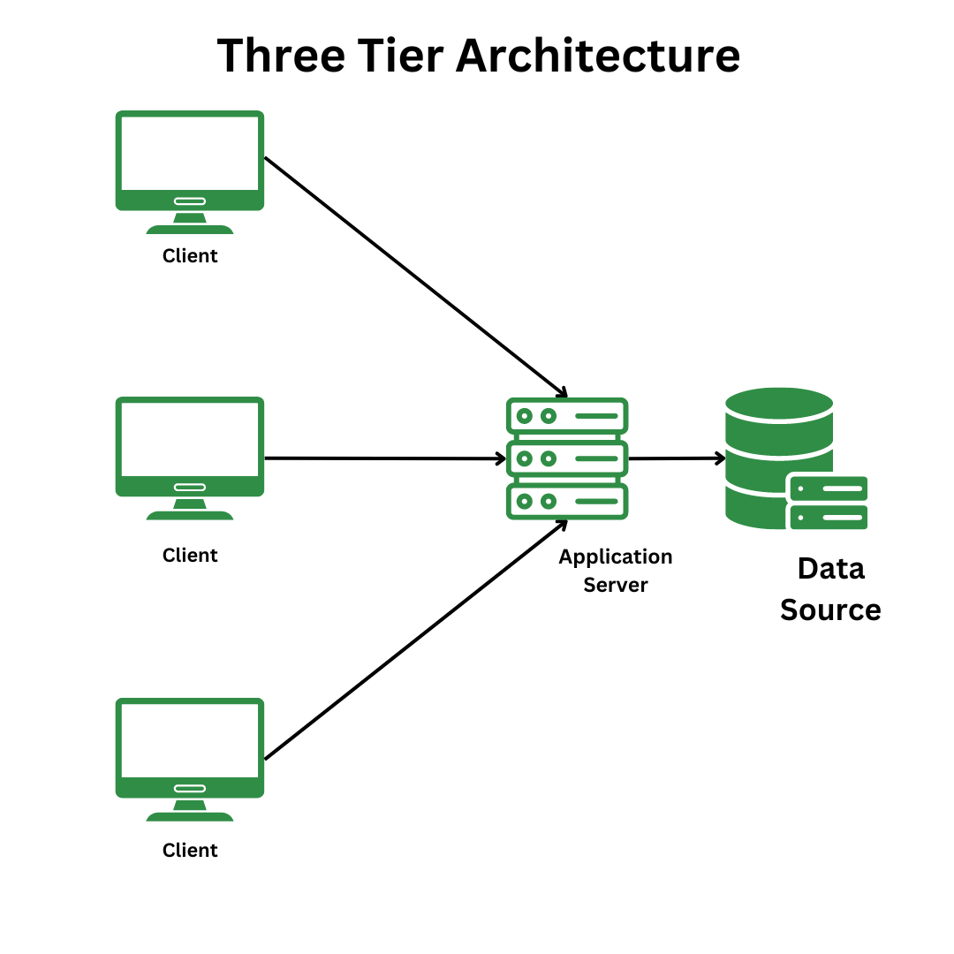
Figure 1 Design architecture

3.3.2 Construction Languages
The main construction languages used in building this project include, React JS with type script, FastAPI for backend and building API end points, MySQL
Javascript is used here as it best suits web applications, it also gives the dormant layout some interactivity. Python in fastAPI is a good example of a server scripting language

3.3.3 Coding
The main approach used for coding this system was the modular approach, which entails writing codes into small reusable components that help improve reusability and reduce code ambiguity

3.4 Software Construction fundamentals
The implementation process is one of the stages where complexity management has to be taken into consideration since the code which will be written by a certain developer D1 at a time T1 may be maintained by another developer D2 at a time T2.

3.4.1 Complexity Management
To manage application complexity, SwiftDrop utilizes a modular component-based architecture. By constructing the UI into reusable components, the development process becomes more efficient, allowing basic elements—such as headers and buttons—to be shared across multiple screens. This modularity not only enhances code reusability but also simplifies debugging and collaborative maintenance.
However, as the application scales, managing data flow via "Prop Drilling" (passing data through multiple nested layers) can become cumbersome and error-prone. To mitigate this, the React Context API was implemented for global state management. This allows the application to share data, such as user authentication or theme settings, globally without manually passing props through every level of the component tree.
For quality assurance and debugging, React Developer Tools were employed to monitor component hierarchies and state changes in real-time, while network tab monitoring was used to manage API requests to the backend logic endpoints.
FastAPI also supports the modular programming architecture which helped in the separation of API endpoints rather than merging everything together, this made the app less cumbersome and understandable

3.4.2 Anticipating Change
It is important to consider that technologies are changing by the day and updates just keep coming in by the day to improve user experience over a wide variety of applications, as a result the application code structure being designed in a modular structure permits for the integration of new features. The app is also deployed in versions so users are aware of the necessary changes

3.4.3 Construction for Verification
To ensure that the system is set for building we need to make sure all requirements in the requirement phase are met, this is important as it gives developers a workflow which they can follow after which the solution is validated to see if it performs as the user demanded

3.4.4 Reuse
It is very necessary to have reusable code structures in our solution, this helps reduce application complexity this solution implements code reuse by implementing a modular based coding structure. In react code is beast written in the form of reusable components which can be called to serve different purposes

3.5 Software Construction tools

3.5.1 Testing tools
Before every software solution comes to the spotlight, it is tested in several use case scenarios to make sure the software is ideal for general purpose use
The API endpoints of this application were tested using the Swagger UI(an open-source tool that automatically generates interactive, visual documentation for RESTful APIs directly from an OpenAPI Specification) which automatically is installed when using Fastapi

3.5.2 Development Environment
The main development environment used was the Microsoft visual studio code editor, this editor supports programming in multiple programming languages such as python and javascript

3.6 Deployment
The deployment phase involves transitioning the application from a local development environment to a live production environment. To ensure high availability, security, and scalability, a suite of DevOps tools was utilized to host the various architectural layers of the application.
- GitHub: Serves as the primary Version Control System (VCS). It facilitates continuous integration by hosting the source code and tracking changes, allowing for seamless updates through its integration with hosting providers.
- Vercel: Utilized for hosting the Frontend (React) application. Vercel offers an optimized edge network that ensures fast load times, automated SSL encryption for security, and support for custom domains.
- Railway / Render: Employed to host the Backend (RESTful API). These platforms provide a robust environment for running Node.js/FastAPI services, ensuring that the logic layer remains accessible and responsive to frontend requests.
- Aiven: Used for Cloud Database Management. Aiven provides a managed MariaDB/MySQL instance with automated backups and high reliability, ensuring data integrity for user and delivery records.
- Cloudinary: Acts as the Cloud Media Provider. It is used to store and manage unstructured data, such as user profile pictures and images of delivery items, providing optimized delivery through their Content Delivery Network (CDN).

3.6 Maintenance
This Application has not met its end yet, several changes will be made based on user feedback to improve the pointed out problems currently faced in this version of the app, Github will be the bridge between the new updates and

3.7 Documentation
To ease maintenance of this solution, A descriptive documentation was created in the repository as a Readme file. This file has a structured outline on the project requirements and the flow of the software.

3.8 Conclusion
This Document showed the various steps involved in the construction of a web application swiftDrop, this proves that the necessary enquiries were made and all requirements were met based on the system needs, the mandatory steps involved in software construction where put into practice such as complexity management, code reuse, debugging and many others without which the project fails to meet its main purpose

